Victory Gardens Theater Annual New Year’s Tour
December 27, 2009 – January 3, 2010

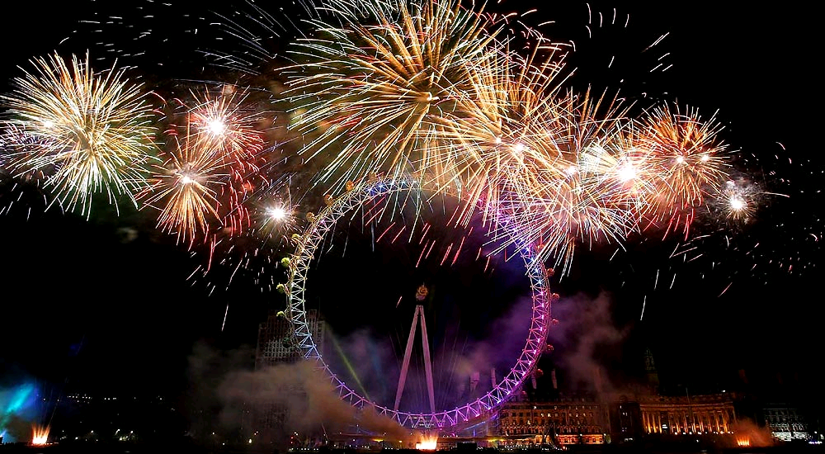

Sunday, December 27

Depart this morning from O’Hare on American Airlines for an evening arrival in Heathrow. You’ll be met by private coach and James Ryan of Insider Cultural Tours and taken to your hotel, Le Méridien Piccadilly. Set in the heart of London’s West End, its many amenities include the Piccadilly Health Club, a Jacuzzi, and one of London’s largest indoor swimming pools. Piccadilly Circus, Leicester Square, and Covent Garden are just minutes from this grand dame of London hotels. Your accommodations include a daily breakfast. Le Méridien Piccadilly. 21 Piccadilly · London W1J 0BH · United Kingdom · Phone: +44 207 734 8000 Fax: +44 207 437 3574

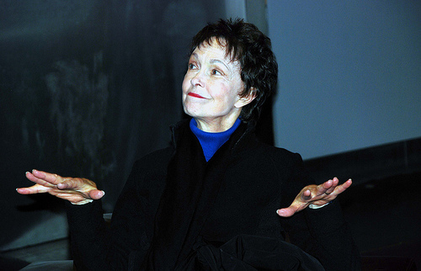
Tony Award winner Deanna Dunagan in post-performance discussion with tour members at National Theatre.
Monday, December 28

Morning
You’ll be greeted and briefed by James Ryan and Dawn McCormick Dean of Insider Cultural Tours. Michael Billington, theatre critic of The Guardian, will join Victory Gardens Theater Artistic Director, Dennis Zacek, for an insightful discussion about the plays we’re going to see, as well as what’s happening in the current London theatre scene (10am, Le Meridien, Adams Suite.)

Afternoon
A private tour of the critical success, Turner and the Masters at Tate Britain. Rivalry, obsession, jealousy... the story of Turner's battle to outdo all other artists (2:30pm private coach departs from Le Meridien to Tate Britain. Coach departs at 5 pm from Tate for the National Theatre.)
.

Evening Performance 1
Habit of Art by Alan Bennett (History Boys) at the National Theatre. Richard Griffiths, who created the role of Hector in Alan Bennett’s The History Boys, plays W. H. Auden. Benjamin Britten, sailing uncomfortably close to the wind with his new opera, Death in Venice, seeks advice from his former collaborator and friend, W H Auden.

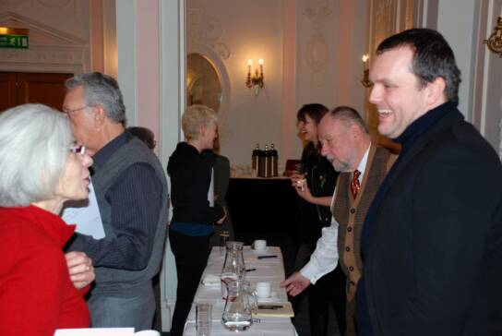
London playwrights Che Walker and Rebecca Lenkiewicz talking with tour members.

During this imagined meeting, their first for twenty-five years, they are observed and interrupted by, amongst others, their future biographer and a young man from the local bus station. (7:30 pm, National Theatre, Lyttelton. Running time and interval is 2hr 35 mins.)

Post Performance Discussion
Immediately following is a private post-performance discussion, moderated by Dennis Zacek, with Richard Griffiths, star of Habit of Art. (Approximately 10:15 pm, Ashcroft Room, National Theatre. Return to hotel by private coach.)

Tuesday, December 29

Morning
Inspired by the Linbury Biennial Prize for Stage Design competition, UK's foremost award for emerging theatre designers, today we’ll discuss the art of stage design with Dennis Zacek and two London practitioners of this often overlooked craft. Our guests will include Mark Friend, designer for the Nation, and Garance Marneur, overall winner Lindbury Prize 2007. (10 am, Adams Suite, Le Meridien.)

Please join us for a private tea in honor of Alfred Molina. An intimate conversation, moderated by Dennis Zacek, about the challenges of mounting Red at the Donmar and an examination of his craft and artistry. This should be an exceptional thrilling event since we’ll see Red soon after our Traditional Elegant Afternoon Tea complete with finger sandwiches, scones with jam and clotted cream, pastries and selection of teas. (3-4pm, Adams Suite, Le Meridien.)

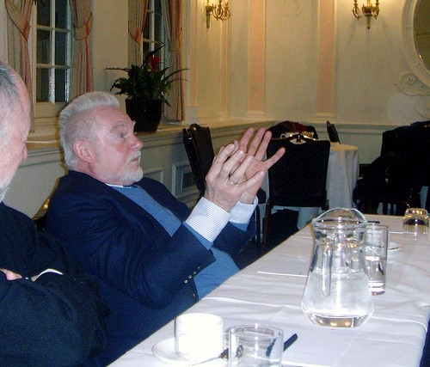
Evening Performance 2
Red, by Victory Gardens Ensemble playwright, John Logan. Under the watchful gaze of his young assistant and the threatening presence of a new generation of artists, Mark Rothko takes on the challenge to create a definitive work for an extraordinary setting. One of the greatest artists of the 20th century whose struggle to accept his growing riches and praise became his undoing .

Sir Derek Jacobi talking to London tour members.

(7:30 pm, Donmar Warehouse, 41 Earlham Street. Running time is 1hr. 45 mins. Jim Ryan will lead a 10 minute group walk to the theater, leaving the hotel lobby at 7 pm.)

Wednesday, December 30

Morning
Please join our discussion, led by Artistic Director, Dennis Zacek, about emerging playwrights in the UK today. Invited guests include Lisa Goldman, Artistic Director of Soho Theatre, Leyla Nazli, Executive Producer, Arcola Theatre, and playwright Kwame Kwei-Armah. (10 am, Adams Suite, Le Meridien.)
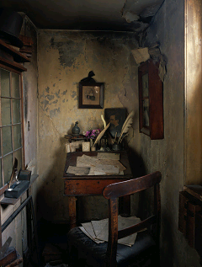

Afternoon
Dennis Severs’ House. Dennis Severs' House is a time capsule attraction in which visitors are immersed in a unique form of theatre. The ten rooms of this original Hugeuenot house have been decked out to recreate snapshots of life in Spitalfields between 1724 and 1914. An escorted tour (mulled wine included) through the compelling 'still-life drama', as American creator Dennis Severs put it, takes you through the cellar, kitchen, dining room, smoking room and upstairs to the bedrooms. With hearth and candles burning, smells lingering and objects scattered apparently haphazardly, it feels as though the inhabitants had deserted the rooms only moments before. (Private coach departs hotel at 2:30 pm. Coach returns to hotel at 5 pm.)

Evening Performance 3
Rope by Patrick Hamilton. Based on a real case, Patrick Hamilton’s dark classic presents a chilling anatomy of a motiveless murder, and a brilliant snapshot of a jazz-age generation wallowing in privilege, booze, parties, a shallow obsession with fashion and films, and a desperate inner emptiness.
Premiered in 1929, and later adapted as a film by Alfred Hitchcock, it is brought back to life at the Almeida by director Roger Michell. Hamilton’s other work includes the play Gaslight (revived at the Old Vic in 2007) and the novel Hangover Square. (7:30 pm, Almedia Theatre, Almeida Street. Running time is 1 hr 50 mins., no interval. Private coach will depart at 6:50pm from hotel for Almedia.)

Thursday, December 31

Morning
Weight in with Artistic Director, Denis Zacek, and exchange views and reactions to all the shows we’ve seen, and the shows we’ll see up ahead (10am, Adams Suite, Le Meridien).

Afternoon Matinee Performance (Optional)
Swan Lake. When it premiered at Sadler’s Wells in 1995, Matthew Bourne's triumphant modern re-interpretation of Swan Lake turned tradition upside down, taking the dance world by storm. Matthew Bourne blends dance, humour and spectacle with extravagant, award-winning designs by Lez Brotherston (2:30 pm, Sadler’s Wells Theatre, Rosebery Avenue. Running time is 2 hrs 30 mins., including one 20 min interval.)

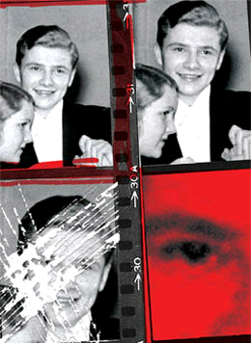

Evening
Le Méridien Piccadilly, Terrace Restaurant. Let’s ring in the New Year with a wonderful New Year’s Eve dinner and with a champagne toast! Above Piccadilly, under glass and sky, discover the Terrace Restaurant and Bar. Known for its distinctive character and majestic charm, The Terrace Restaurant and Bar at Le Méridien Piccadilly offers traditional fine dining in a breathtaking atmosphere that features natural light, classic stone pillars and contemporary design. (Dinner begins at 10:30 pm.)

Friday, January 1

Evening Performance 4
Nation. Following His Dark Materials, Coram Boy and War Horse, the National stages Mark Ravenhill’s exhilarating adaptation of Terry Pratchett’s latest witty and challenging adventure story. A parallel world, 1860. Two teenagers thrown together by a tsunami that has destroyed Mau’s village and left Daphne shipwrecked on his South Pacific island, thousands of miles from home. Daphne delivers a baby, milks a pig, brews beer and does battle with a mutineer. Mau fights cannibal Raiders, discovers the world is round and questions the reality of his tribe’s fiercely patriarchal gods (7:30 pm, Olivier, National Theatre. Running time 2 hrs 25 mins, including interval. Private coach departs hotel at 6:30 pm for National Theatre. Return to hotel by private coach.)
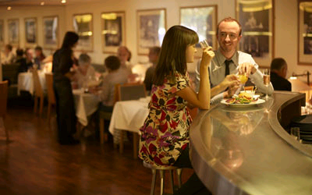

Saturday, January 2

Morning
A critical roundup with Artistic Director, Denis Zacek (10am, Adams Suite, Le Meridien.)

Optional Matinee Performance

The Priory by Michael Wynne. Michael Wynne’s buoyant new comedy takes a microscope to modern dilemmas about life, love and retro board games. Kate is delighted when she finds a country retreat that ticks all the boxes. Gathering together a select group of her closest friends to celebrate New Year’s Eve, she is keen to start 2010 afresh. But successful, stressed-out thirtysomethings in search of a good time in the sticks can make for one very fearsome party…and some surprising resolutions.

Michael Wynne’s previous plays include The People Are Friendly and The Knocky for the Royal Court, and Sell Out, Dirty Wonderland and The Boy Who Left Home. He also co-wrote the film My Summer of Love (3:00 pm, Royal Court Theatre. Running time is 2hr. plus 1 interval. Private coach departs immediately following performance, 5:20 pm, for the Mezzanine Restaurant at the National Theatre.)

Pre-Theatre Dinner
Our Farewell dinner will be conveniently located at the Mezzanine Restaurant, housed in National Theatre on the Southbank, overlooking the River Thames – all the better to take a nice post-dinner river stroll just before our last show. (Dinner starts at 5:50 pm.)

Evening Performance 5
The Pitmen Painters by Lee Hall (inspired by a book by William Feaver). Winner, Best Play, Evening Standard Awards, Pitmen is “ablaze with intellectual vigour, political passion and incendiary emotional energy. A beautiful work of art that everybody should see,” raves the Times.
In 1934, a group of Ashington miners hired a professor to teach an art appreciation evening class. Rapidly abandoning theory in favour of practice, the pitmen began to paint. Within a few years the most avant-garde artists became their friends and their work was acquired by prestigious collections; but every day they worked, as before, down the mine. Lee Hall’s new play is a humorous, deeply moving and timely look at art, class and politics (7:30 pm, National Theatre, Lyttelton. Running time is 2 hrs. 30 min, including interval. Return to hotel by private coach.)
Sunday, January 3
Private Coach departs hotel for Heathrow at 2 pm. American Airlines, Flight 91V, departs Heathrow at 4:30 pm, arrives O’Hare at 7:40 pm.

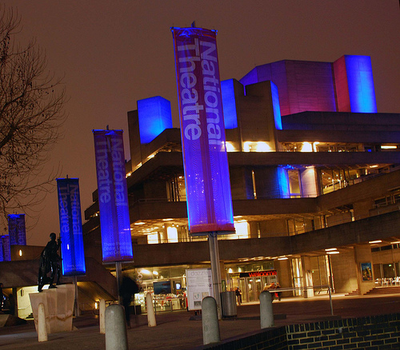

COST
$5,050 (includes $500 tax-deductible donation to Victory Gardens Theater). Price includes guaranteed airfare ($506) on American Airlines but DOES NOT INCLUDE Fuel + Taxes + Ticketing Fee, which, currently, are estimate to be an additional ($406.70). Price does not include cost of optional shows.

Single room supplement: $1484

